PBS Evolution
The Mind’s Big Bang

- In which continent did modern humans first evolve?

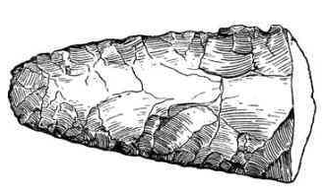

- What tool did the Paleolithic people make? What was its purpose? How long did they continue to use this tool?

- How long ago did the first hominids split from the common ancestor with chimpanzees?

- How long ago did modern humans leave Africa and begin settling in other continents?

- If the 100,000 year-old Israeli skull and the 40,000 year-old African skull are physically similar, how are the two species different?

- Why is the discovery of beads and ornaments in the Ucazili settlement significant?

- How did ancient humans produce beads differently than we do now?

- What social meaning did the beads and clothing produced by Cro-Magnon (early modern) humans have?

Cro-Magnon Humans and Neanderthals

- Compare and contrast the two hominids; Cro-Magnons and Neanderthals.
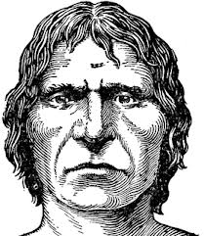
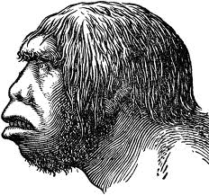

 | Cro-Magnon Humans | Neanderthals
Physical Appearance
Burials
Spear Design
Teaching and Learning
Art and Communication

- How did the early humans create cave paintings?

- What other artistic expression may have been created in the caves?

- Do you think the human brain the result of a single mutation, or a combination of many mutations?

- Compare the correction of bad behavior in humans and chimpanzees.

- What is the “theory-of-mind” ability that is absent in three year-old children, but mastered in five year-olds? Do chimpanzees have this ability?

- When does the “window for language” begin to close? What happened to deaf people in Nicaragua that were not exposed to language during this time?

- When a group of deaf children without language were brought together, what happened?

- What is the single biggest use of verbal language (two-thirds) in human species?

- What other ways might language have been useful and an advantage to the early humans?

- If genes are the building block of biological evolution, what kind of evolution might memes build?

- Has cultural evolution ended biological evolution? Would you consider this to be unhealthy or detrimental to our species?

